Template for drafting an AI use case
Perseus - AI-based system for extracting knowledge, managing risks and supporting organisational processes
1. Main area
Select the area to which the use case primarily belongs:
- ☐ Strategy, Governance and Organisation
- ☐ People, Skills and Ways of Working
- ☐ Data, Technologies and Infrastructure
- ☒ AI Applications and Value Creation

2. Challenge or opportunity
There are a few major common problems across many organisations:
- how to store and share knowledge
- how to manage and handle risks
- how to quickly get context about a specific issue
- how to learn from previous errors or successes
In everyday life in an organisation, a lot of data is processed from different sources. Emails, documents, events, reports, etc. This information is not stored as structured and organised data. It stays in email clients, on laptop disks, in the cloud, etc., and:
- context is lost
- information is fragmented
- knowledge is not accessible
- decisions are not related to issues
In short:
- To handle issues and make good decisions, you need to learn from previous bad or good decisions.
- To learn from the past, you need to have knowledge with the whole context.
- To have knowledge, you need to have structured and organised data.
- To have structured and organised data, you need a tool which can turn unstructured document chaos into structured, searchable knowledge that the whole team can rely on. This is the challenge.
- For data processing, you can use people, but that is a waste of human potential. Or you can use AI. This is the opportunity.

3. Proposed use of AI
Resource -> LOCAL AI MODEL -> structured data -> organised knowledge
AI could handle the time-consuming task of reading and analysing large volumes of documents, extracting summaries, identifying risks and categorising content automatically. It would process unstructured information such as PDFs and emails and turn it into structured, actionable knowledge.
But this data often contains very sensitive information. This is also the most important part of the solution: the LOCAL AI MODEL. In the future, there will be a strong demand for solutions which are 100% local-based, where the processed data is accessible only within the local infrastructure.
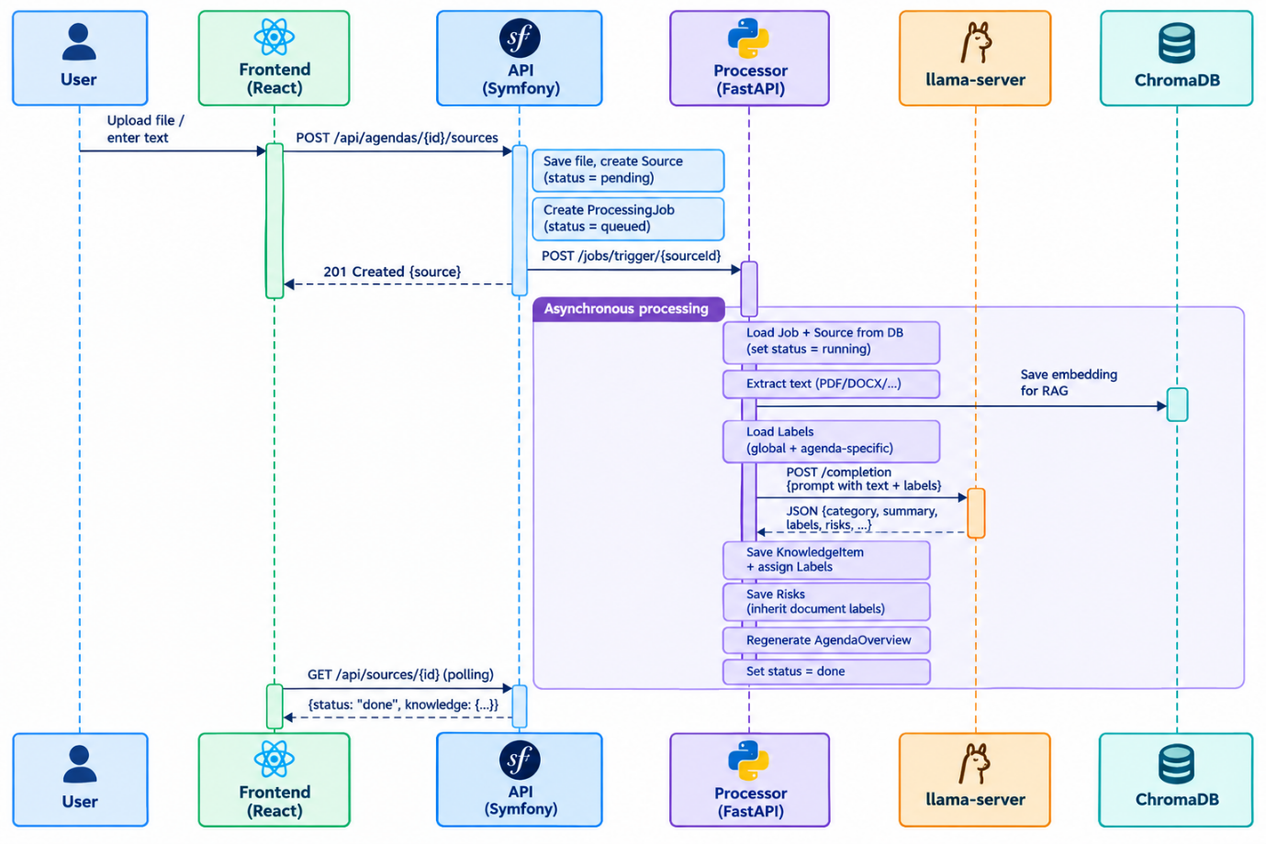
Pic.1: Current working Perseus schema

4. Scope
Process covered: uploading and AI-processing of documents, extracting risks, tasks, events, summaries and knowledge items, and maintaining a shared agenda knowledge base.
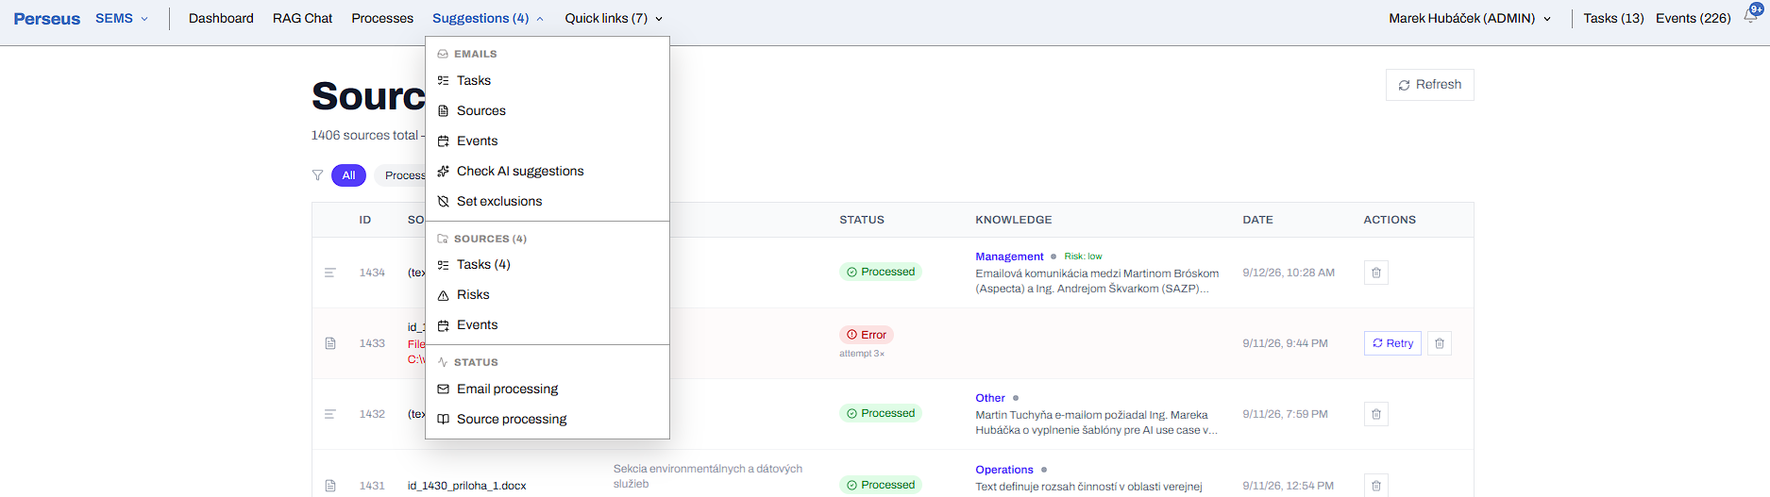
Pic.2: Overview of source processing in Perseus

Main users: project managers, agenda owners, team members and workspace administrators
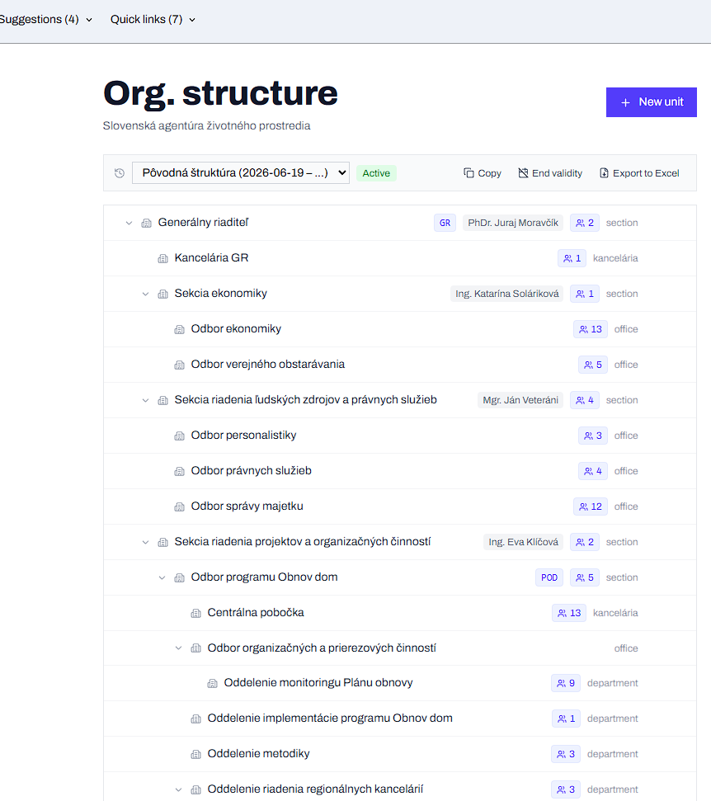
Pic.3: Overview of user, roles, organization structure in Perseus
Data involved: uploaded files such as PDFs, Word documents and spreadsheets, raw text, emails and AI-generated outputs such as summaries and risk assessments. Structured data is stored in JSON format, in a vector database (ChromaDB) and a relational database (PostgreSQL).Out of scope: autonomous decision-making, video and audio media processing, media generation
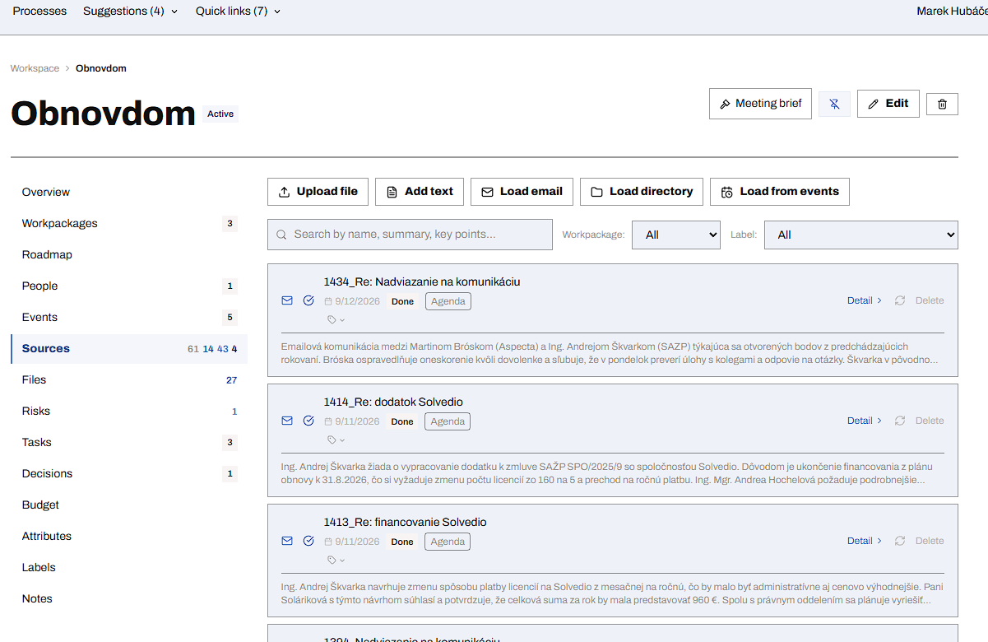
Pic.4: Overview of agenda resources in Perseus

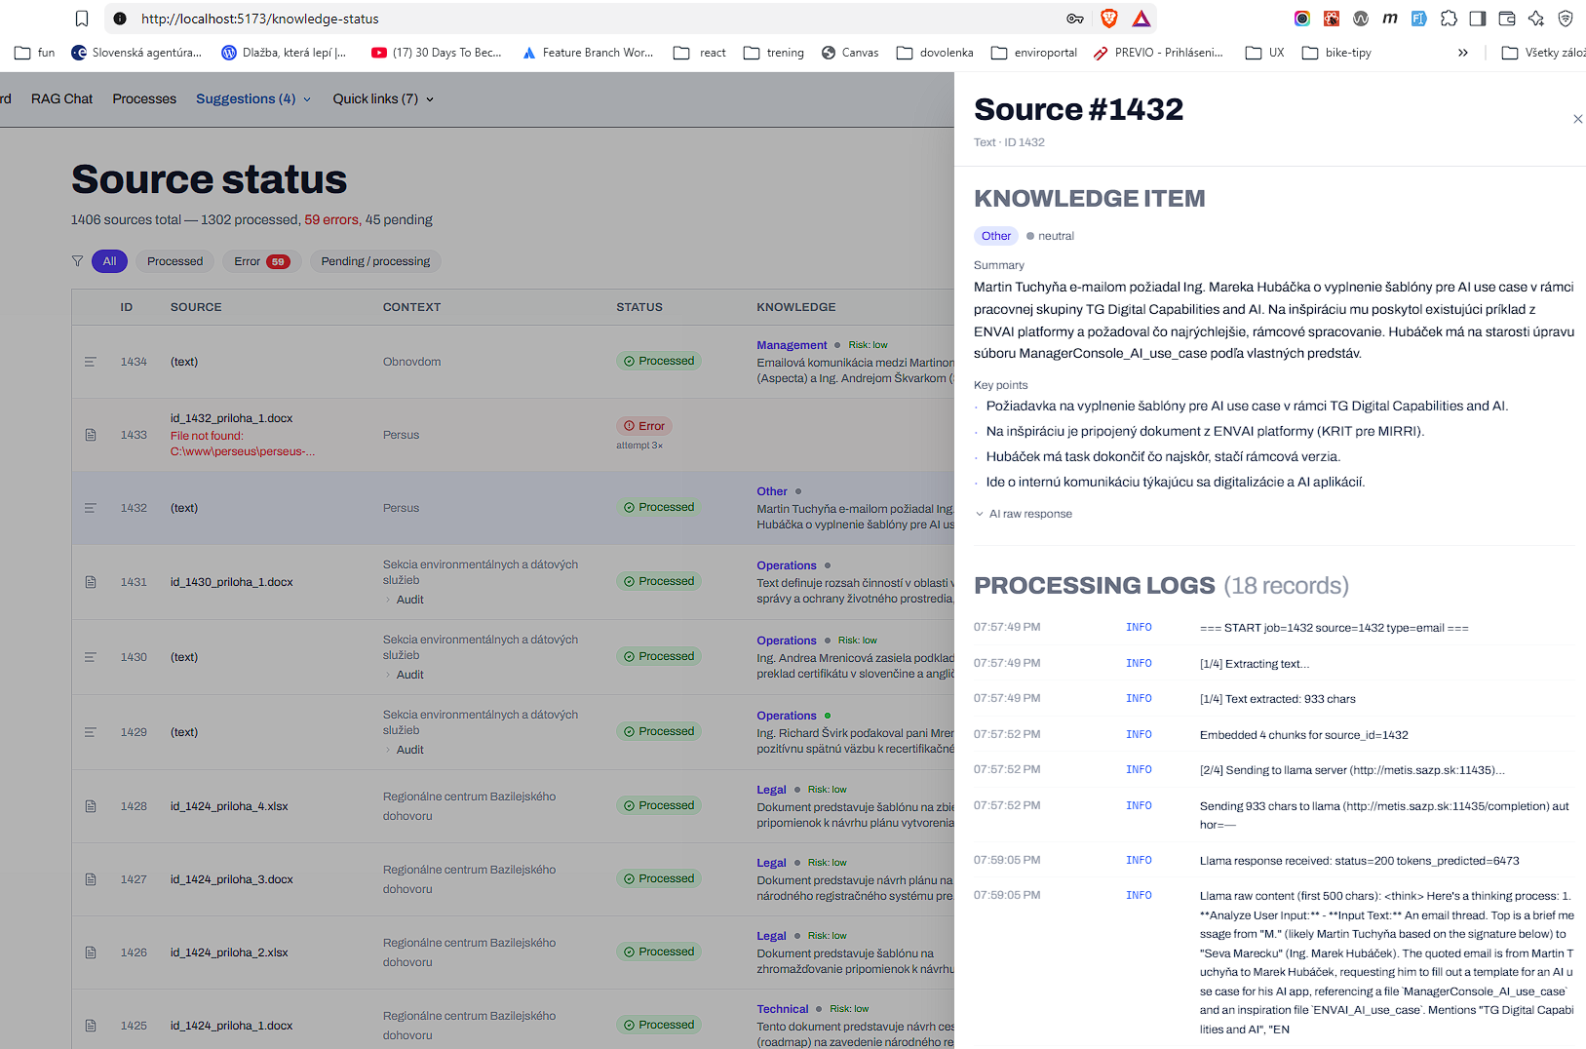
Pic.5: Detail of resource AI processing in Perseus

5. Expected outcome
Perseus is running in a testing phase and is currently used only by a very small group of users. It is already producing some results, but the expected final outcomes are more ambitious.
There are many more areas for improvement, such as HR management, security, financial management and physical resource management. The following are the most important:
Risks management:
AS IS:
- can identify risks from sources using AI
- can generate risk matrix
- can manage risk mitigation
EXPECTED:
- can learn from previous risks and suggest the best solution
- can suggest probability and impact according to the context
- can identify experts and required skills to handle risks
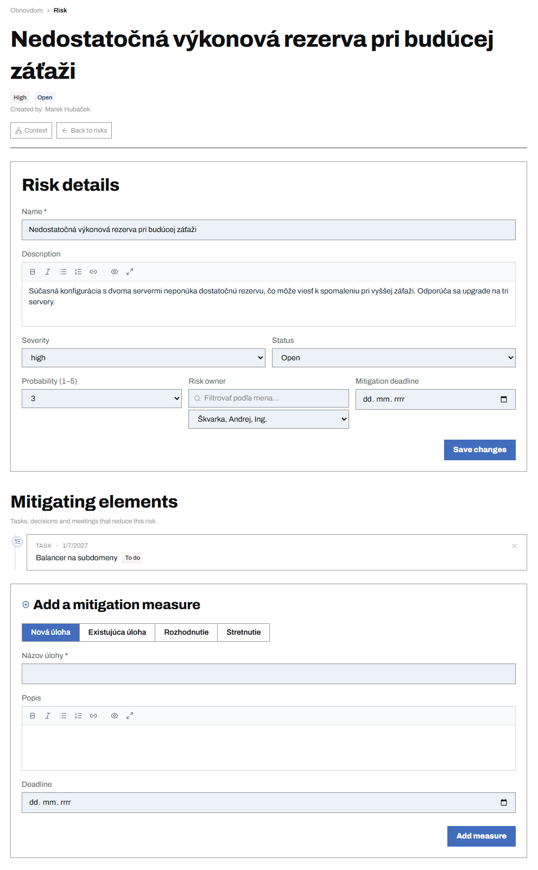
Pic.6: Risk mitigation in Perseus

Decision making:
AS IS:
- can store decisions with a relation to risks and tasks
- can provide context of decision
- can store decision metadata, including the decision maker and the decision
EXPECTED:
- can learn from previous decisions and suggest the best decision
- can identify similar previous decisions and suggest improvements
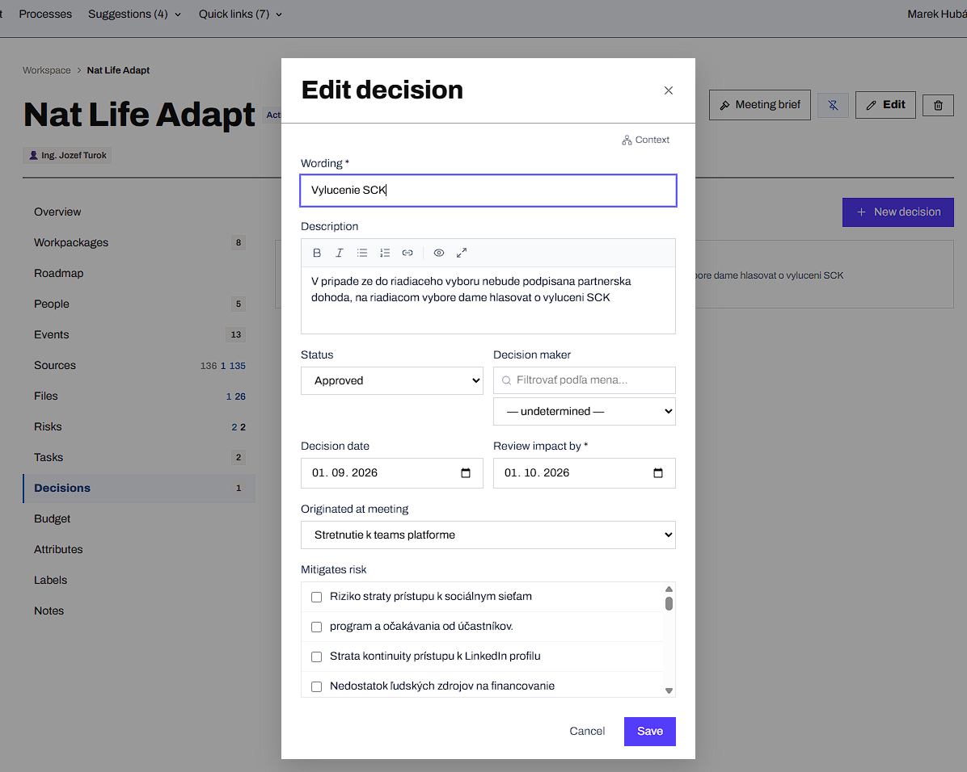
Pic.7: Decision managment in Perseus

Knowledge:
AS IS:
- can store structured data about resources
- can store files with relations to risks, tasks, events and decisions
- can identify risks, tasks, events, people and organisations from resources
- can generate agenda report
- can generate actors activity reports
- can generate materials for meetings
- can identify critical tasks and risks
- can generate a multilevel view for top management – risks, running processes, tasks, HR data and financial data
EXPECTED:
- interactive chat based on ChromaDB data
- More detailed and accurate reports
- a wide range of possible processing resources and MCP servers over the local infrastructure
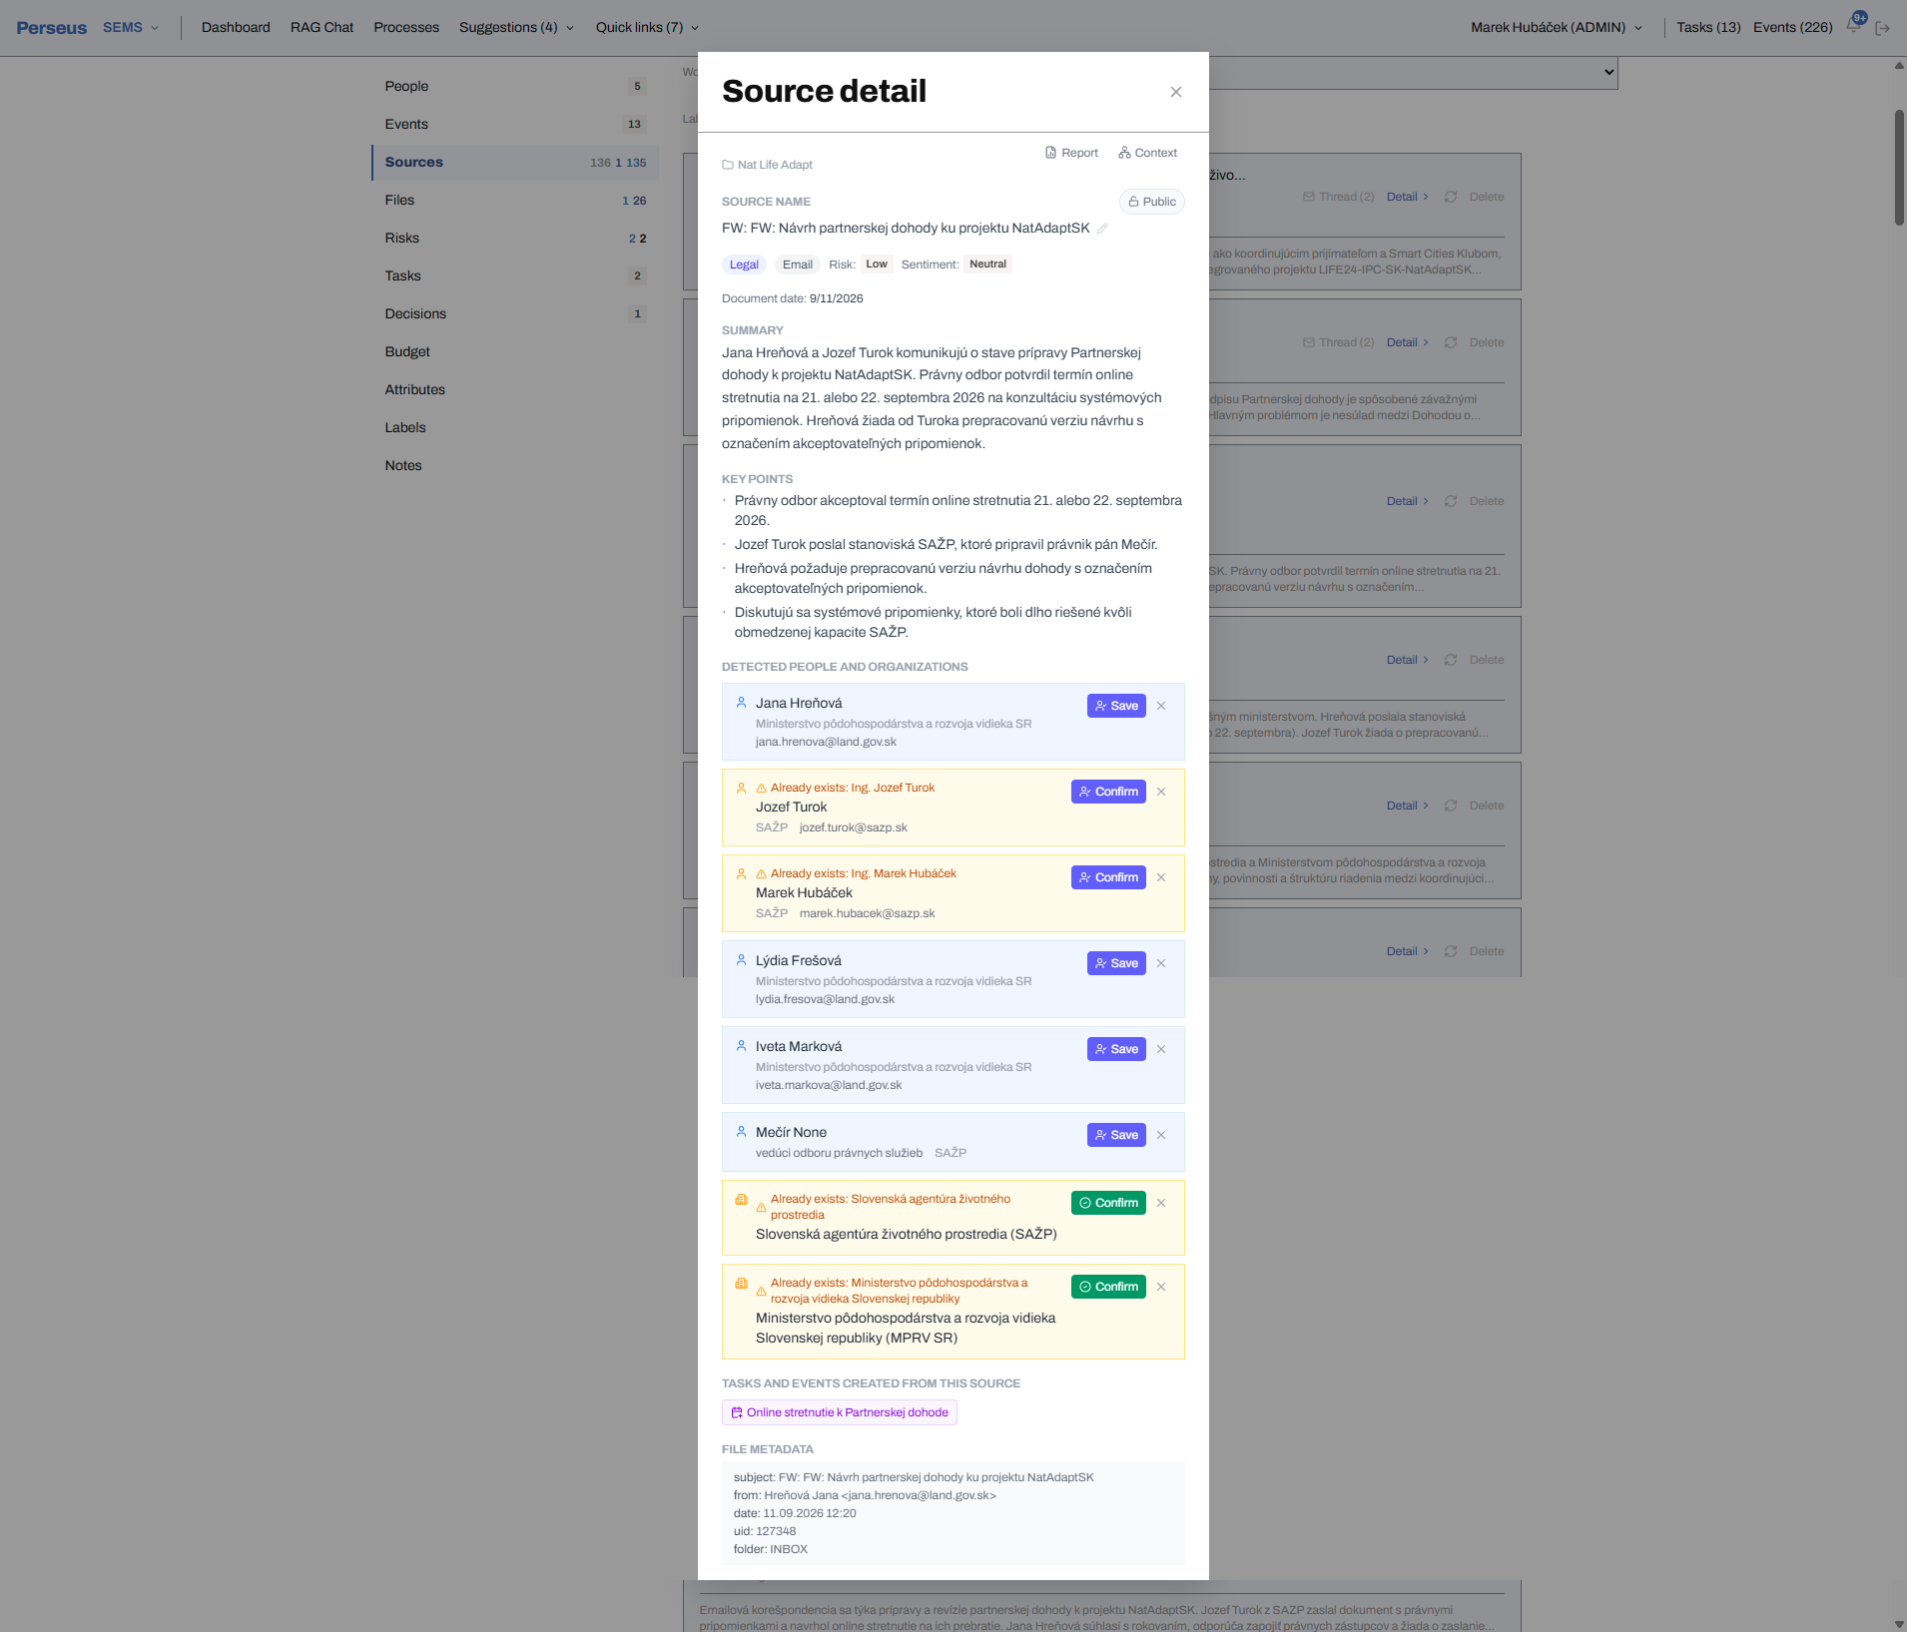
Pic.8: Knowledge source detail in Perseus

Process management:
AS IS:
- can manage 3 basic processes
EXPECTED:
- covering most used processes in the organisation
- admin area for defining new processes
- storing process development and history
- learning from process history
- identifying possible process improvements
- Pic.8: Knowledge source detail in Perseus
- Pic.8: Knowledge source detail in Perseus
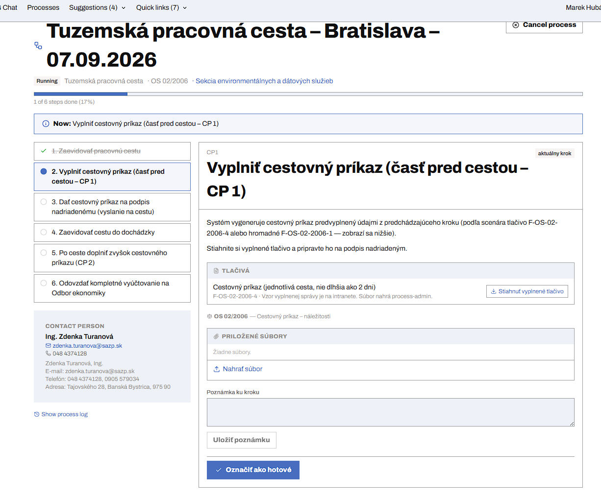
Pic.9: Process detail in Perseus

6. Contribution to the environment and digital agenda
Perseus can help environmental organisations to process and use information from environmental documents, reports and assessments. It can make relevant information easier to find and use when preparing materials and making decisions.
On the digital side, Perseus helps automate routine work while keeping people in control of the results. It improves knowledge sharing, data accessibility and cooperation across organisational units. It also helps build practical AI skills inside public and environmental organisations.

7. Key conditions and considerations
- Data quality and availability: the system is only as good as the documents provided to it. Incomplete, poorly structured or outdated information can lead to unreliable AI outputs.
- Privacy and security: documents processed by Perseus may contain sensitive or confidential information. Access to the data must therefore be properly controlled and data ownership must be clearly defined.
- Responsible AI and human oversight: AI-generated risks and summaries must be reviewed by qualified people. AI output should support people, not replace their judgement.
- Regulatory compliance: depending on the organisation, AI-assisted document processing may need to comply with GDPR and other regulations related to data handling and automated decision-making.
- Technical infrastructure: Perseus depends on several services running at the same time – the Symfony API, Python processor, llama server and ChromaDB. This makes reliability and maintenance important.
- Skills and capacity: staff need sufficient digital skills to use the system effectively and to critically evaluate AI outputs.

